Planet Youth Funders Wicklow

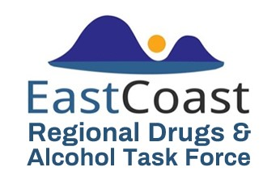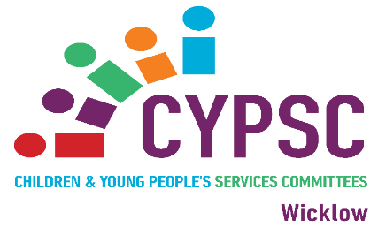

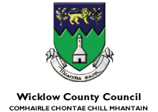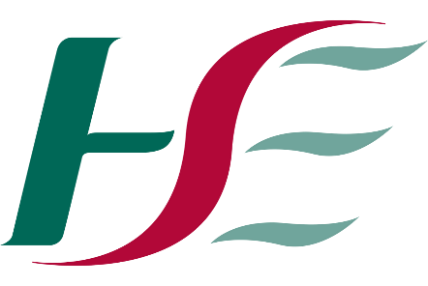

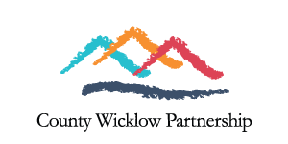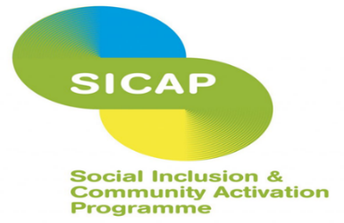

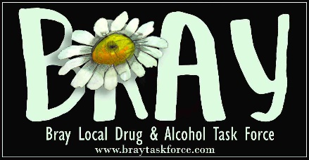

Ethical Approval Supported by RCSI



Ethical Approval Supported by RCSI

Planet Youth
Wicklow

Parent/Guardian Information Leaflet and Opt-Out Form

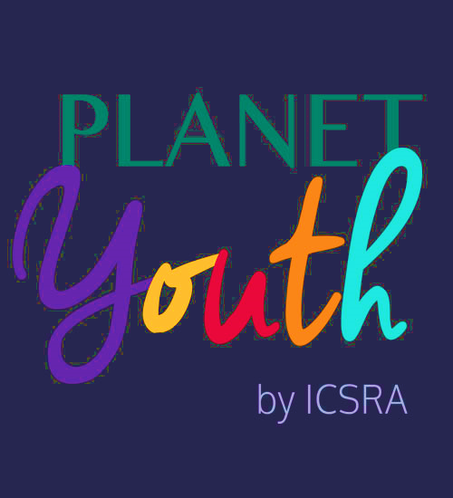

What is Planet Youth?

Planet Youth came from Iceland. In the 1990’s, studies showed they had one of the worst youth drug and alcohol use among teens in Europe. A research study and prevention model was developed called the Icelandic Prevention Model. This model has led to huge improvements in Iceland and the model is now being adopted successfully in other parts of Europe including Ireland. It is mostly now referred to as Planet Youth.
It is a five-year programme that involves carrying out an anonymous survey with young people between the ages of 15-16 every second year throughout the programme (year one, three and five). The survey looks at all aspects of a young person’s life.
A Planet Youth Committee is formed from a mix of services who work with young people across the county from education, justice, health and wellbeing, children’s services, sport, drugs and alcohol.
The Committee comes together following the survey results and decides on actions to take. The years in between the surveys are used to act upon results. Future surveys will show what has worked or what has not and determine future responses and survey questions in line with real time evidence and emerging trends.
For further info see: www.planetyouth.org

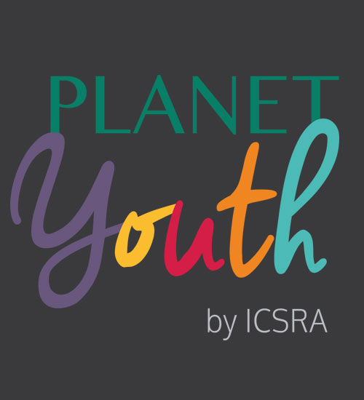

The Survey Process

The survey link is received to school/youthreach devices and completed anonymously by individual students in schools/youthreach.
The survey consists of a number of questions that will take the student approximately 60 minutes to complete.
Once the survey has been completed and submitted by the student, it is automatically received by the university expert team in Reykjavik, Iceland.
The data is analysed, evaluated and returned within 40 days to the Planet Youth team as whole Planet Youth site data and each education centre can request their own anonymous data.
The Planet Youth team attend a workshop with Iceland experts to interpret the data and recommended actions based on the results.
Collaboration of stakeholders/Planet Youth team resumes to ensure whole community responses to data are continuously implemented.

Welcome to Planet Youth! To opt out, please sign below and return to your Planet Youth Coordinator.

Planet Youth Opt Out Form.

Dear ____________________________
(Name of Education Centre)

I wish my child to be opted out of the
Planet Youth programme.

Thank you.

Signed ___________________________

Date: ______/________/____________

The Planet Youth Five Year Programme!

Year One: Students/youths complete the survey.

Year Two: The Planet Youth team collectively coordinate to put actions in place to respond to the survey results.

Year Three: Students/youths complete the survey.

Year Four: The Planet Youth team collectively coordinate to put actions in place to respond to the survey results.

Year Five: Students/youths complete the survey …

